**Project Design Phase-I**

**Solution Architecture**

|  |  |
| --- | --- |
| Date | 19 SEP 2022 |
| Team ID | PNT2022TMID07372 |
| Project Name | Smart Waste Management for Metropolitan Cities |
| Maximum Marks | 4 Marks |

**Solution:**

The proposed system constructed to the top of the bins to detect bin level status and alert the admin through a cloud service-based application.The application provides a monitoring platform for the waste management institution to handle the alert records by creating orders for the garbage collectors/drivers which can be accessed via a mobile application system

**Solution Architecture Diagram:**

**ULTRASONIC SENSOR**



**USER END (CLOUD BASED WEB APPLICATION)**

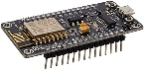

**NODE MCU**

**MICROCONTROLLER**

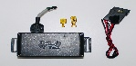

**GPS TRACKER**

**LOAD CELL**

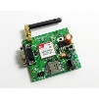

**GSM SIM MODULE**